**Admin User Flow**

Admin user will have the Nav bar different color from the regular user and mainly can be able to perform the

1. Add Products
2. Edit Products
3. Delete Products
4. Manage Orders
5. Process Orders
6. Delete Orders

Admin - Profile Page

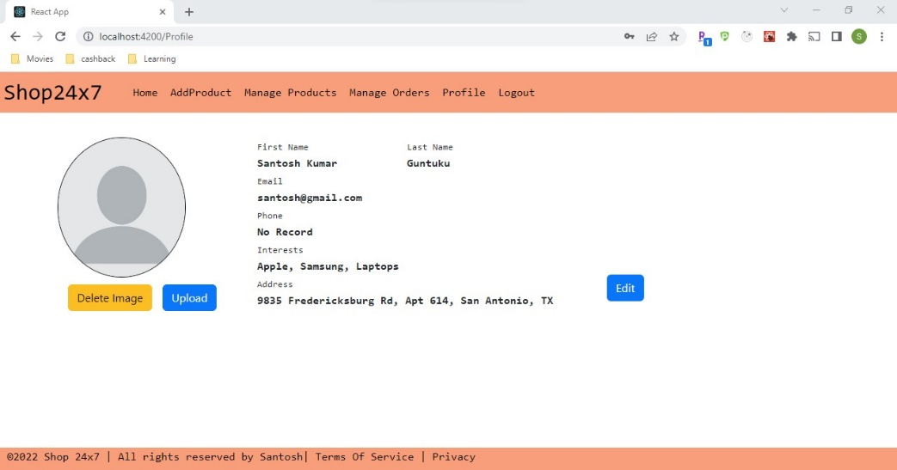

Add Product – <http://localhost:4200/admin/add-new-product>

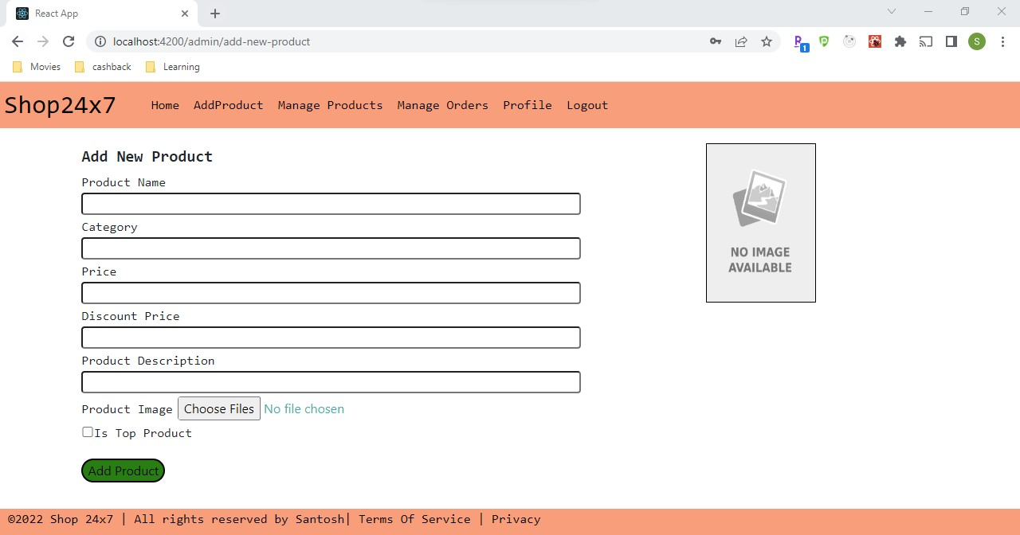

After Add Product Success – Admin will be shown message to navigate to Manage Products

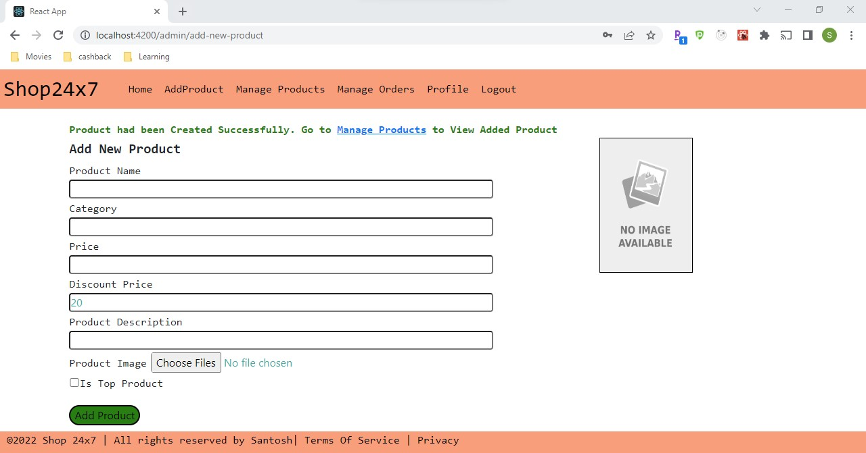

Manage Products – <http://localhost:4200/admin/products> where admin can edit/delete the products

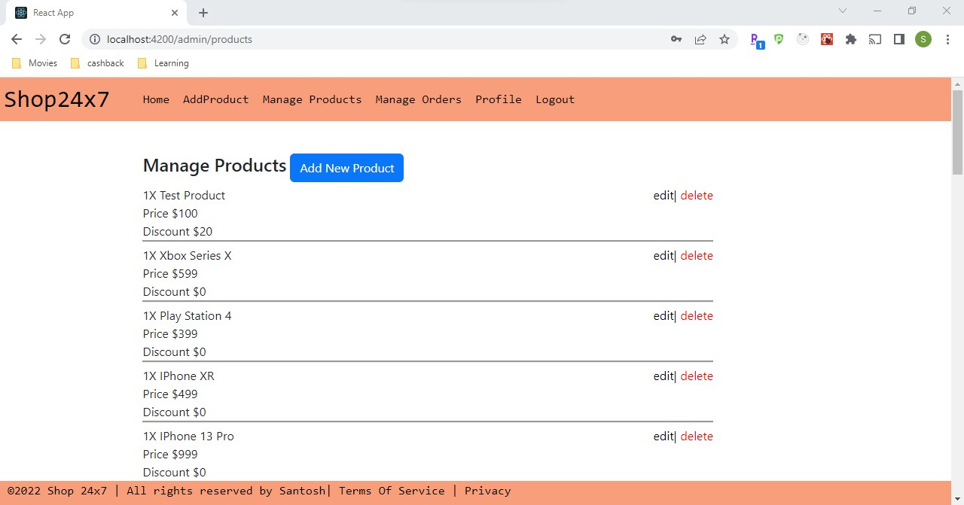

Edit Product – <http://localhost:4200/admin/products/62f05fee2b0955019c1964f5/edit>

After success edit Admin will be navigated directly to Manage Products Page

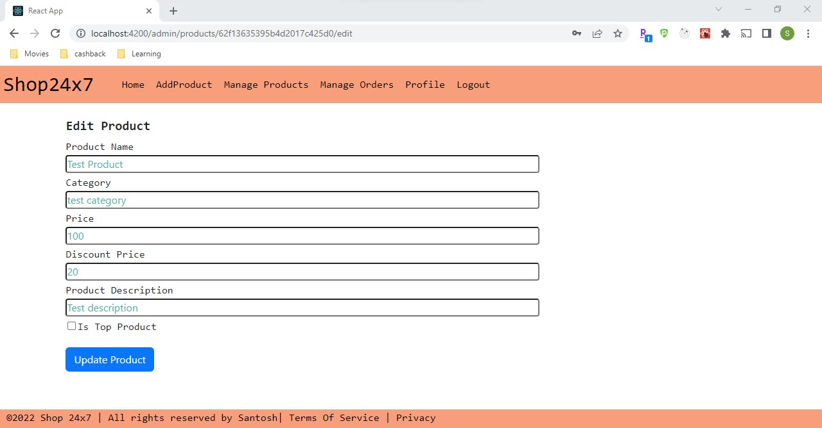

Delete Product –Admins can be able to delete the product on click of delete button.

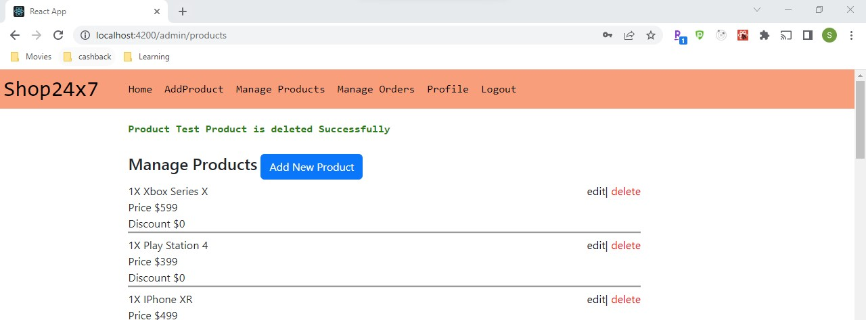

Admin can be able to Manage Orders from Manage Orders Page - <http://localhost:4200/admin/orders>

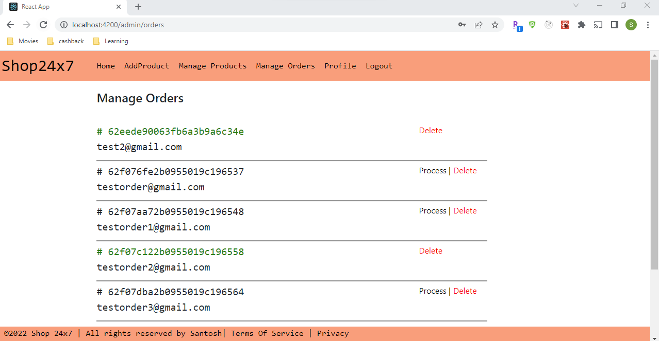

Admin has option to delete Order and Process Order

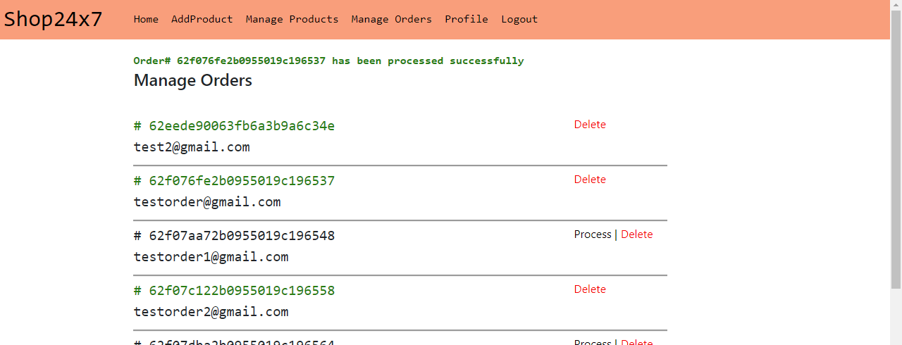

Delete Order

